35.38: a) For Jan, the total shift was 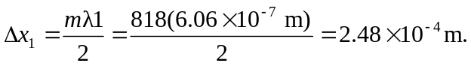
For Linda, the total shift was 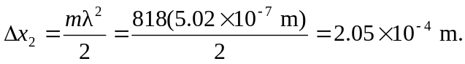
b) The net displacement of the mirror is the difference of the above values:

